Aggregation is a powerful tool for transforming and filtering data. https://youtu.be/vx1C8EyTa7Y

Find all users with isActive:true in db and count them

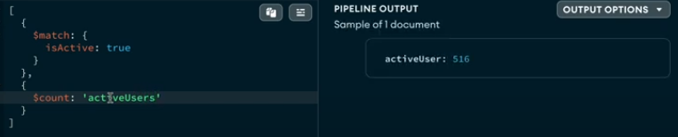

What is the average age of all users (null selects all data, $avg is a accumulator function)



group the people based on gender

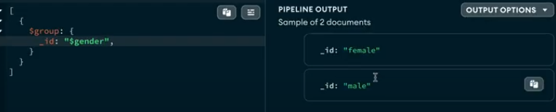

avaerage age of all users based on gender

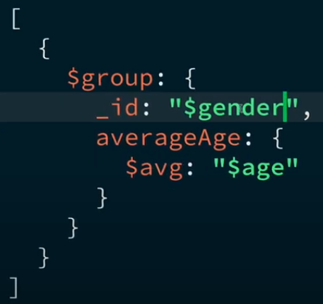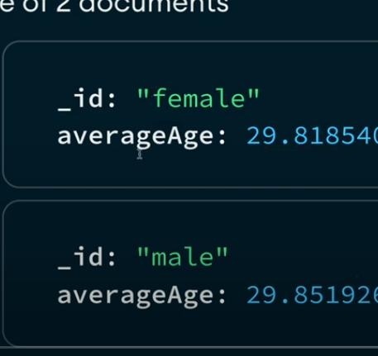

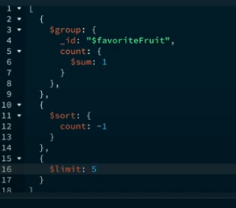

list top 5 most common fruits in db

count all males and females in dataset

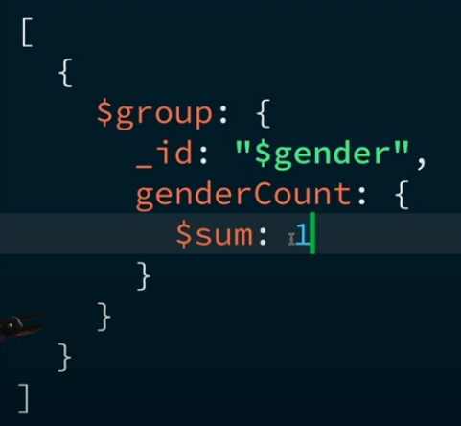

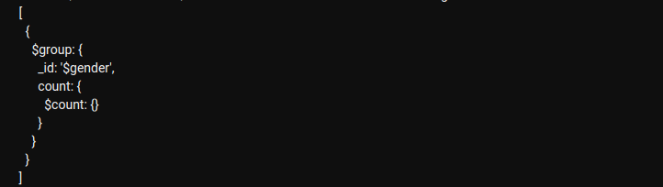

or

$count is generally used for counting no of documents in a stage.

Which country has highest number of registered users

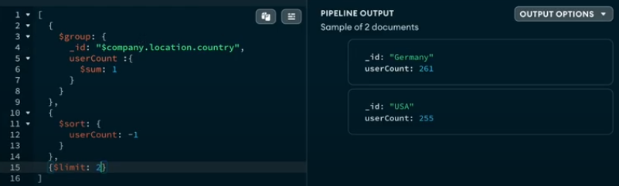

What is the average number of tags per user

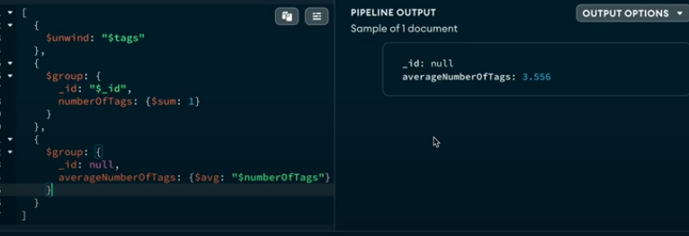

or the above one can also be done by ($size:”$tags” this could also be done but it wont cater null value)

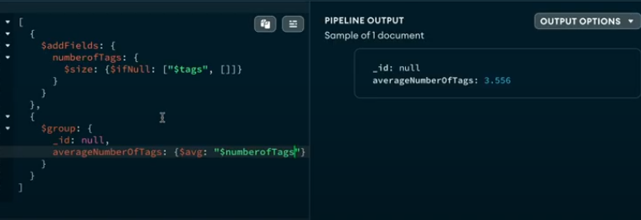

just for one we can do

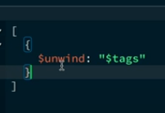

How many users have ‘enim’ as one of their tags?

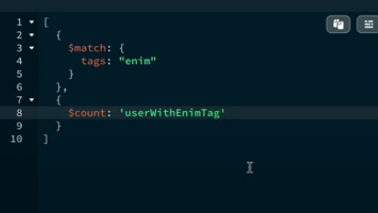

What are the names and age of users who are inactive and have ‘velit’ as a tag?



Count all users with a string +1 940



Get last 4 most recently registered users

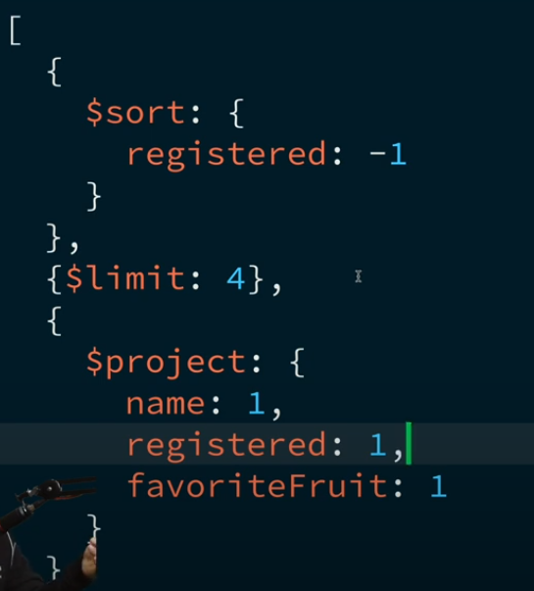

Categorize users by their favourite fruit

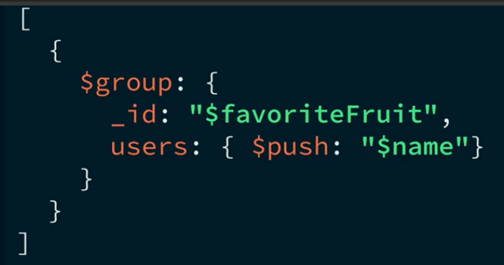

How many users has ‘ad’ as second tag in their list of tags

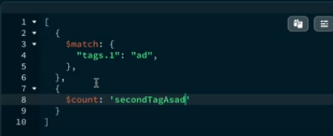

Find users who have both enim and id as their tags

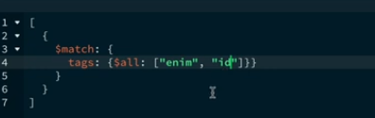

list all companies located in USA with their corresponding user count

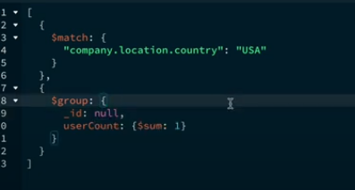

$lookup

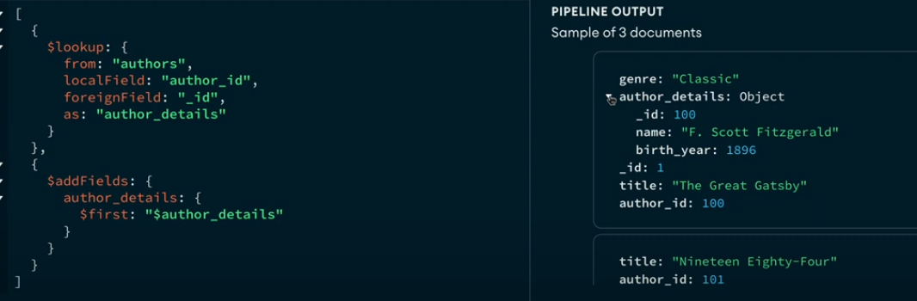

or

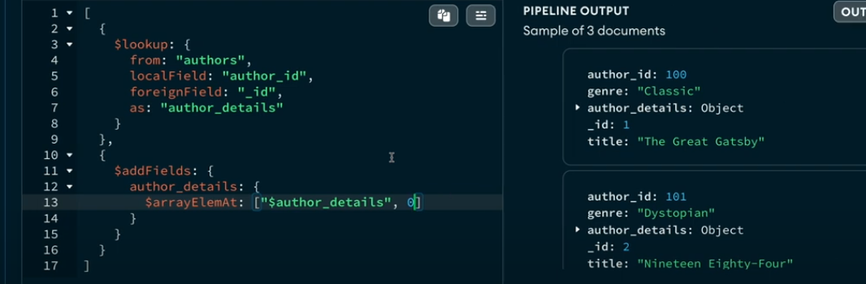

data for above:

